Easter Holidays | Read | Watch | Listen/Do/Play
Week 1 (6th April – 12th April) | Mum, Dad, Alzheimer’s and Me – You Tube. Real life story investigating the care of Alzheimer’s sufferers in the UK. https://www.youtube.com/watch?v=LprTLaO1AF0  Old age/disorders  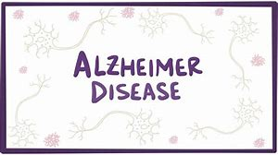 | TV programmes:  Babies : their wonderful world – BBC. Explores how the first 2 years of life shapes the adults we become. Infancy development/life stages | Rio and Kate: becoming a step family. Rio Ferdinand’s fiancée Kate Wright integrates into the family as a step mum  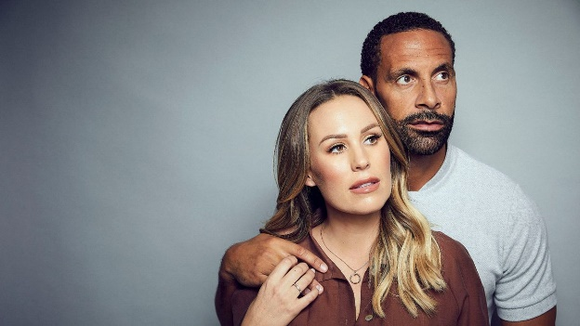  Please follow @Team_MaltbyPE on Twitter to keep an eye on physical things to do during the holidays.
Week 2 (13th April – 19th April) | The Nine to Five with Stacey Dooley https://www.bbc.co.uk/iplayer/episode/p06zhfvw/the-nine-to-five-with-stacey-dooley-series-1-2-caring-and-sharing Stacey Dooley takes five teenagers to a care home for work experience. Types of support/voluntary support/old age | Born to be different – Channel 4. The pressures and joys of bringing up a disabled child  https://www.channel4.com/programmes/born-to-be-different/ Disability/infancy and childhood/life events. | - Crisis in Care: BBC Panorama https://www.bbc.co.uk/programmes/m0005jpf Panorama reveals the failings of our social care system, as our population gets older and more of us need help with day to day living. Old age/care services  Please follow @Team_MaltbyPE on Twitter to keep an eye on physical things to do during the holidays.

