Easter Holidays | Read | Watch | Listen/Do/Play
Week 1 (6th April – 12th April) | Factfulness: Why things are better than you think  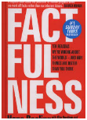 | The Hunger Games Trilogy – currently available on Netflix  “May the odds be ever in your favour” …  The story is centered on a 16-year-old girl, Katniss Everdeen and her struggle for survival in dystopia. Each year, as a punishment for the failed rebellion by District 13, the 12 Panem Districts are forced to pay tribute to the ruthless Capitol regime. | Monopoly – Whoever is the winner gets to make up the rules of the house for a day! This is known as being the ruling class  Please follow @mltsociology on Twitter to keep an eye on articles or further documentaries to watch
Week 2 (13th April – 19th April) | Happy: Finding joy in every day and letting go of perfect  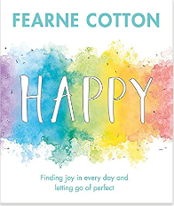 | Tiger King – currently available as a limited series on Netflix  An exploration of big cat breeding and its bizarre underworld, populated by eccentric characters. | Mindfulness/Yoga - YouTube videos for every intention! Give your mind and body focus.  Please follow @mltsociology on Twitter to keep an eye on articles or further documentaries to watch

