Easter Holidays | Read | Watch | Listen/Do/Play
Week 1 (6th April – 12th April) | 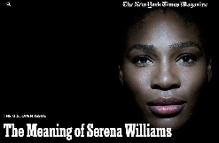  In 1995 Serena Williams became a professional tennis player, following in the steps of her sister Venus. Her career has been remarkable and she has been celebrated as the greatest ever female tennis player. John McEnroe has claimed she is the best player, irrespective of gender, to ever play the game.  The Bleacher Report claims this New York Times article is one of the top ten sports articles of the last five years.  https://www.nytimes.com/2015/08/30/magazine/the-meaning-of-serena-williams.html | 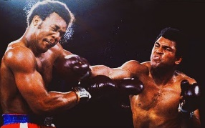  In 2002, Will Smith portrayed the greatest boxer of all time, Muhammad Ali in the movie ‘Ali’. The movie told the story of his life and built up towards his most famous boxing match, the ‘Rumble in the Jungle’  Journalists gave Ali no chance against a much younger and stronger George Foreman, who at this time was Heavy Weight Champion of the World.  The clip below is HBOs coverage of the fight that saw Ali regain the heavy weight title for a record 3rd time. Sporting history!  https://www.youtube.com/watch?v=55AasOJZzDE&t=3119s  The next clip is of a famous interview between British presenter, David Frost and Muhammad Ali.  https://www.bbc.co.uk/iplayer/episode/p00nxzvw/the-frost-interview-david-frost-interviews-muhammad-ali | 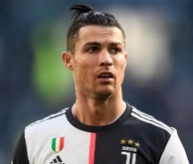  The G.O.A.T? Many believe that Cristiano Ronaldo is the greatest football to have graced the game. Pele, Maradona, Ronaldo (R9), Ronaldinho and Messi, in such esteemed company does CR7 really top the list?  The link below is a 2015 interview between Ronaldo and BBC reporter Dan Roan.  https://www.bbc.co.uk/programmes/p074j7sv  Please follow @Team_MaltbyPE on Twitter to keep an eye on physical things to do during the holidays.
Week 2 (13th April – 19th April) | 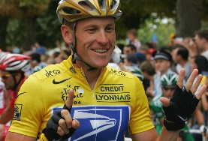  ‘Win at all costs’ is a state of mind that creates extraordinary performance from athletes, performances that seem beyond comprehension and human physiology. When we see the performances and successes that leave us scratching our heads and mumbling the words, “that’s not possible”; we want to believe in god like athletes, often these gods are nothing short of cheats.  The article below details the ‘controversial’ life of Lance Armstrong.  https://www.biography.com/athlete/lance-armstrong | A look back at the best bits of Sport Relief 2020.  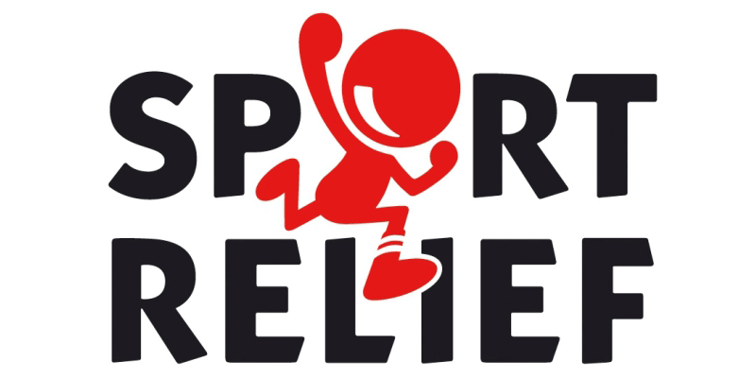  http://www.bbc.co.uk/iplayer/episode/m000ggwy  3 of the best Sport Relief sketches  - https://www.youtube.com/watch?v=Uq_cwwWcyqQ  - https://www.youtube.com/watch?v=f8fgmmdKVMo  - https://www.youtube.com/watch?v=w7YBuMhKhXE&t=173s | In a powerful and thought provoking Podcast England Lioness Eni Aluko discusses her identity, race issues and footballing success with Sports Psychologist Gary Bloom.  https://podcasts.apple.com/us/podcast/on-the-sporting-couch-eniola-aluko/id1112143535?i=1000458339254  Please follow @Team_MaltbyPE on Twitter to keep an eye on physical things to do during the holidays.

