Easter Holidays | Read | Watch |  | Listen/Do/Play
Week 1 (6th April – 12th April) | The big debate!!  Love Pizza? Yes we do too!! Read about the best way to hold your pizza!  https://www.wired.com/2014/09/curvature-and-strength-empzeal/  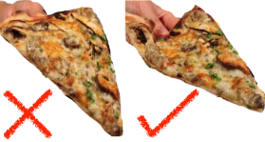  Practise your Maths whilst playing games!  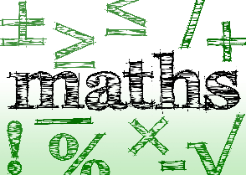  https://www.coolmath4kids.com/  Have fun!! | Imitation Game (PG) – Staring Benedict Cumberbatch  “Are you paying attention?” breathes Benedict Cumberbatch’s Alan Turing in the opening moments of this handsomely engrossing and poignantly melancholic thriller from Norwegian director Morten Tyldum.  A tale of plucky British ingenuity underpinned by an acknowledgement that Turing, as Gordon Brown put it, “deserved so much better”.  The Imitation Game is not a tragedy – rather, it is a celebration of Turing’s extraordinary achievements, a populist yarn that makes an admirably firm fist of establishing its spiky subject as a heroic outsider.  Alan Turing – Celebrating the life of a genius  https://youtu.be/gtRLmL70TH0
Week 2 (13th April – 19th April) | Loop the loop  Some people love rollercoasters, some people hate them! But... why are the loops not perfect circles?  Check out the Maths behind it!  http://www.datagenetics.com/blog/march42014/index.html | Good Will Hunting (15) – Staring Matt Damon & Robin Williams  The most brilliant mind at America's top university isn't a student, he's the kid who cleans the floors. Will Hunting is a headstrong, working-class genius who is failing the lessons of life. After one too many run-ins with the law, Will's last chance is a psychology professor, who might be the only man who can reach him. Finally forced to deal with his past, Will discovers that the only one holding him back is himself.  Hidden genius?  https://youtu.be/OSGaGSG5S5U |  | Rock, Paper, Scissors  We all love a game of Rock, Paper, Scissors don’t we!! Here is the logic behind how you could win!  http://digg.com/video/mathematic-strategies-that-will-help-you-win-at-rock-paper-scissors
Social Media | Please follow @mamaths2 on Twitter for Maths information, celebrations, challenges and tips over the holidays |  | Follow @misslaceymaths on Instagram for amazing maths tip pages and solving problems in 10 second videos

