Easter Holidays | Read | Watch | Listen/Do/Play
Week 1 (6th April – 12th April) | Victorian Lives  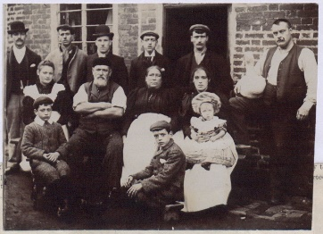  How different was life in Victorian times? Follow this link to the National Archives to find a range of information to read, sources to investigate and tasks to do  Read a report about a female teacher, Victorian entertainment and the story of a railway accident, amongst other features of the time  https://www.nationalarchives.gov.uk/education/resources/victorian-lives/#tasks | Worst Jobs in History  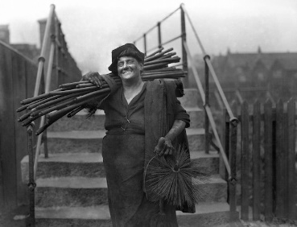  Chimney sweep, tanner or railway navvy? Just what is the worst job in history. These 12 45 minute videos look at different periods of time, examining what horrible things people had to do just to make a living.  Travel through time with historian Tony Robinson as he tries out each of the jobs. Watch him collect leeches, make matchsticks and work in Henry VIII’s palace.  One job is so smelly that it had to be done away from all the towns and villages! Just what is the Worst Job in History?  https://www.youtube.com/playlist?list=PL63D956BC489378A5 | 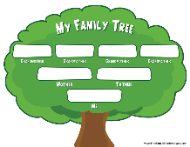  Family Tree. Interview the people you live with to find out about their backgrounds. You might be able to find some old pictures or historical artefacts or even create a family tree.  The Maltby History team will be setting up a local history webpage and we’d love to share your stories / pictures / medals / items from history.  You may have an elderly family friend / relative who would love to share their stories over the phone… especially if they are stuck in on their own.  Please send us any interesting photos you find about WW1, WW2 and Coal Mining to help build our webpage.  Send them to: ma-history@maltbyacademy.com
Week 2 (13th April – 19th April) | This Day in History  Get you daily dose of history by following the link below. Each day it will show you what major events have happened on the same date throughout history, Click on each story that you want to learn more about.  https://www.history.com/this-day-in-history | Blitz Street  What would it have been like to live in a house that was bombed during WW2?  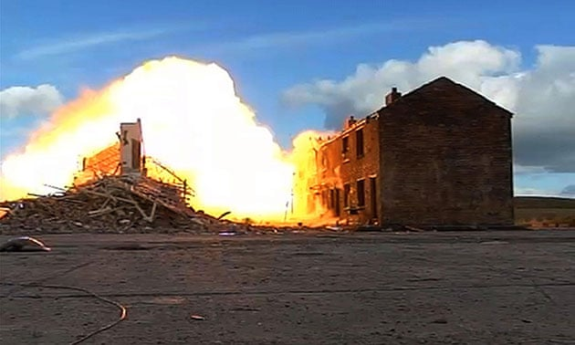  https://www.youtube.com/watch?v=OVEtLLeJ0s4I  Tony Robinson’s team have built a row of houses on a military base. Now they are going to destroy it using bombs from WW2. Watch the four episodes to find out what British people were faced with as Hitler sent over bigger and bigger bombs. An explosive watch! | 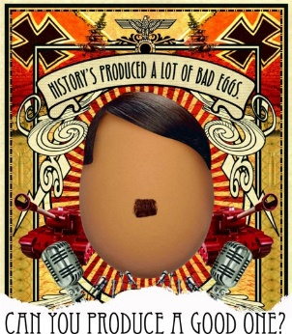  A smashing project!  Boil an egg or eggs, make them look like a person, people or scene from history and take a photograph to show us.  Follow this link for some ideas of what you could create:  https://www.tggsacademy.org/node/3476  Send pictures of your eggs to: ma-history@maltbyacademy.com  We would love to see what you’ve created.

