Easter Holidays | Read | Watch | Listen/Do/Play
Week 1 (6th April – 12th April) | If Hitler asked you to electrocute a stranger would you?  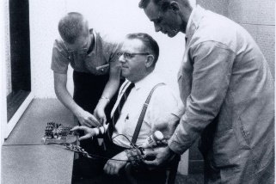  In the beginning, Stanley Milgram was worried about the Nazi problem. He doesn’t worry much about the Nazis anymore. He worries about you and me, and, perhaps, himself a little bit too. Stanley Milgram is a social psychologist, and when he began his career at Yale University in 1960 he had a plan to prove, scientifically, that Germans if Hitler asked You to Electrocute a Stranger would you? Philip Meyer explore this further in this article.  https://www.simplypsychology.org/Milgram%20-%20Obedience.pdf | In 2015 Louis Theroux visits Ohio state psychiatric hospitals who met patients that had committed violent crimes whilst in the grip of severe mental illness. They were found not guilty by reason of insanity and were ordered to secure psychiatric facility to receive treatment. It is spilt into two parts.  https://www.bbc.co.uk/iplayer/episode/b05nyysy/louis-theroux-by-reason-of-insan  https://www.bbc.co.uk/iplayer/episode/b05pwyl0/louis-theroux-by-reason-of-insanity-part-2  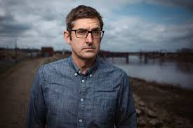 | 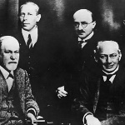  Psychoanalysis and its Legacy-  Is Psychoanalysis relevant today?  Can we use Freud’s theories as a foundation for how we treat mental health today or are his ideas irrelevant and old fashioned? Is there any place for psychoanalysis in today’s world?  https://www.bbc.co.uk/sounds/play/p00545cg
Week 2 (13th April – 19th April) | Overrated: The predictive power of attachment  Psychologist Elizabeth Meins discusses whether the power of attachment is overrated or underrated. Attachment theory has been used for Public Health Englands posters but is this justified? Will insecure attachment necessarily lead to a life of substance abuse and a life of crime?  https://thepsychologist.bps.org.uk/volume-30/january-2017/overrated-predictive-power-attachment | Extreme OCD Camp episode 1 BBC Documentary 2013 journey to the American wilderness  https://www.youtube.com/watch?v=zAXjq28Wpyk  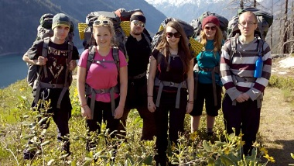  Documentary following six British teens and young adults with obsessive-compulsive disorder as they embark on an incredible journey to the American wilderness for treatment. During the week-long intensive camp, the group undergo exposure therapy, where they are challenged to confront their greatest fears. The group are challenged physically and mentally as they grapple with the demands of camping in a remote environment while undergoing intensive therapy for their OCD. | Elizabeth Loftus and Eye Witness testimony  Claudia Hammond meets Elizabeth Loftus, the psychologist whose research into eye witness testimony and the fallibility of memory changed how police and courts deal with witnesses.  https://www.bbc.co.uk/programmes/b00yhv36

